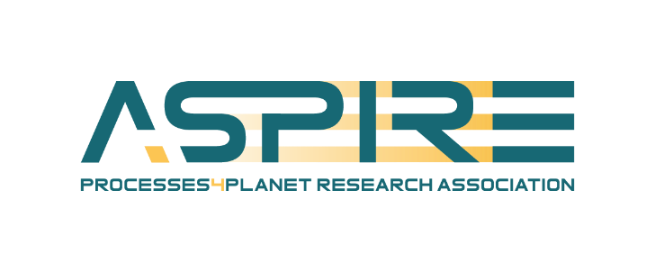

Memorandum of Understanding
(A.SPIRE Membership)

[name of company, RTO, association], represented by [the person authorised to engage [name of company/RTO / organization] in the A.SPIRE legal entity

and A.SPIRE aisbl, represented by Pierre Joris, A.SPIRE’s Chairman

sign the following Memorandum of Understanding:

Both partners intend to participate in the Co-programming Partnership

Processes4Planet (P4Planet)

Transforming the European Process Industry for a Sustainable Society

- Processes4Planet Partnership aims to contribute to reaching climate neutrality, circular economy and a competitive process industry in alignment with the objectives of the Paris agreement, the European Green Deal and the EU Circular Economy Action Plan.
- Processes4Planet is a cross-sectorial R&I partnership that addresses the whole value chain – from different types of feedstock, including renewables, through industrial transformation into intermediate and end-products.
- Processes4Planet will be governed and implemented by a specific legal entity, A.SPIRE aisbl, functioning as a counterpart to the European Commission. A.SPIRE was created on 18 July 2012 and represents more than 170 industrial and research process industry stakeholders from over twenty countries in Europe. A.SPIRE was founded through the joint efforts of the chemical, steel, engineering, minerals, non-ferrous metals, cement, ceramics and water sectors. Since 2020, A.SPIRE also represents refineries and pulp and paper sectors. Other sectors may join the association in the future.
- [Name of company, RTO, organisation] is willing to participate in Processes4Planet Research, Development and Innovation Projects and to contribute to A.SPIRE and to the implementation of Processes4Planet Roadmap (Annex 1).

I confirm that I have read and approved the A.SPIRE aisbl statutes (Annex 2) and that [name of the company, RTO, association] is a legal entity according to the statutes article 6.

Date | Date
Signature | Signature  Pierre JORIS, President
[Name of company, RTO, association] | A.SPIRE

Memorandum of Understanding
(A.SPIRE Membership)

[name of company, RTO, association], represented by [the person authorised to engage [name of company/RTO / organization] in the A.SPIRE legal entity

and A.SPIRE aisbl, represented by Pierre Joris, A.SPIRE’s Chairman

sign the following Memorandum of Understanding:

Both partners intend to participate in the Co-programming Partnership

Processes4Planet (P4Planet)

Transforming the European Process Industry for a Sustainable Society

- Processes4Planet Partnership aims to contribute to reaching climate neutrality, circular economy and a competitive process industry in alignment with the objectives of the Paris agreement, the European Green Deal and the EU Circular Economy Action Plan.
- Processes4Planet is a cross-sectorial R&I partnership that addresses the whole value chain – from different types of feedstock, including renewables, through industrial transformation into intermediate and end-products.
- Processes4Planet will be governed and implemented by a specific legal entity, A.SPIRE aisbl, functioning as a counterpart to the European Commission. A.SPIRE was created on 18 July 2012 and represents more than 170 industrial and research process industry stakeholders from over twenty countries in Europe. A.SPIRE was founded through the joint efforts of the chemical, steel, engineering, minerals, non-ferrous metals, cement, ceramics and water sectors. Since 2020, A.SPIRE also represents refineries and pulp and paper sectors. Other sectors may join the association in the future.
- [Name of company, RTO, organisation] is willing to participate in Processes4Planet Research, Development and Innovation Projects and to contribute to A.SPIRE and to the implementation of Processes4Planet Roadmap (Annex 1).

I confirm that I have read and approved the A.SPIRE aisbl statutes (Annex 2) and that [name of the company, RTO, association] is a legal entity according to the statutes article 6.

Date | Date
Signature | Signature  Pierre JORIS, President
[Name of company, RTO, association] | A.SPIRE

